Implementing Trauma-Informed Systems of Care:
Highlighting the Role of Organizations in Employee Well-Being

Joni Handran PhD, LCSW, CACIII
2150 W. 29th Ave, Suite 330
Denver, CO 80211
jonihandran.com
jonihandran@yahoo.com
720.261.7042

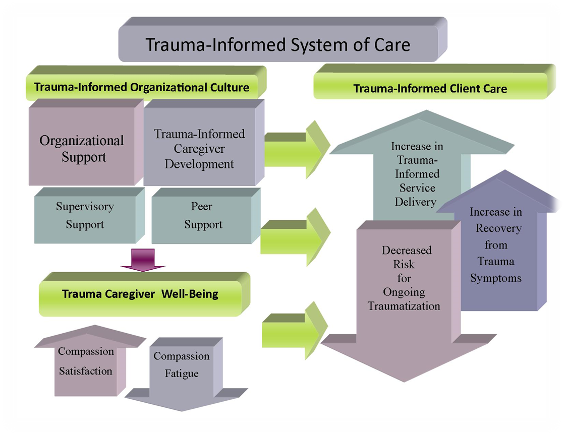

Helpful Resources
Mathieu, F. (2012). The compassion fatigue workbook: Creative tools for transforming compassion fatigue and vicarious
trauma. New York, NY: Taylor and Francis.

Substance Abuse and Mental Health Services Administration. Trauma-Informed Care in Behavioral Health Services.
Treatment Improvement Protocol (TIP) Series 57. HHS Publication No. (SMA) 13-4801. Rockville, MD: Substance Abuse and Mental Health Services Administration, 2014.

Van der Kolk, B. (2014). The body keeps the score. New York, NY: Viking Penguin.

Van Dernoot Lipsky, L., & Burk, C., (2009). Trauma-stewardship: An everyday guide to caring for self while caring for
others. San Francisco, CA: Berrett-Koehler, Inc.

