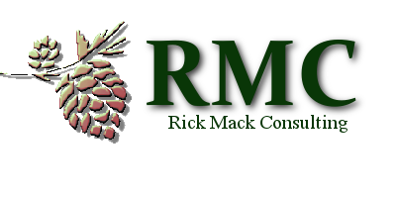
SUCCESSION PLANNING
A WISE INVESTMENT IN YOUR FUTURE
CBHC Conference – October 7, 2017

Session Outline

- What is Succession Planning?

- What is the Difference Between Workforce Contingency Planning & Succession Planning?

- Strategic Talent Management

- Why Invest in Succession Planning?

- Building Your Team with Strong Core Values

- Getting Started with Succession Planning

- Assessing Your Current Situation

- Preparing to Create Goals for Your Program

- What Skills & Knowledge Will You Need in the Future?

- Sample Succession Planning Tools

  - Gap Analysis
  - Growth & Development Pipeline
  - Talent Evaluation Matrix
  - “Nine Box” Evaluation Tools

- Summary

