Health

**2020 Golden Abacus Award**

***for Best Practices in the Non-Clinical Arena***

***This year, CBHC will be utilizing a virtual platform for our conference. We will still accept nominations for the Golden Abacus Award; however, we will acknowledge the winner after the conference in a special ceremony****.*

We encourage you to submit your nomination not only to CBHC but also to include information on your project in our Poster Hall within the virtual platform. Please review the following information:

The Committee of Data, Finance and Budgeting is currently accepting nominations for the Colorado Behavioral Healthcare Council’s (CBHC) annual Golden Abacus Award. Nominees in this category must pertain to programs within the community behavioral health system. The award will be granted to a project, methodology, technology system, or procedure that demonstrates ***best practice in the non-clinical arena****.* All nominations will be evaluated on the following criteria:

* **Innovation**
* **Integration**
* **Quality Improvement**
* **Transferable**
* **Usefulness**
* **Patient/Client Experience**
* **Data-driven Solution**

The winning program will be one that is **easily replicated at any community behavioral health center or provider organization.** Its implementation will result in a superior service, process, or product (i.e. cost reduction, outcome improvement, and enhanced patient/client/staff experience). Results must be data-driven. The committee will consider proposals that demonstrate innovative approaches to the management of, or implementation of, systems or organizations. Submissions may be in the areas of:

* **Research/Research Findings**
* **Finance**
* **Personnel**
* **Quality improvement**
* **Systems/services/program integration**
* **Use of technology**
* **Partnerships/alliances**

***All proposals must include a fifty (50) word Abstract, a Program Description (limited to 2 pages) that includes program development information, innovative aspects, and pertinent data. Please use the following form.***

***We also encourage you to UPLOAD YOUR PROJECT TO OUR CONFERENCE’S ONLINE PLATFORM POSTER PAGE TO SHOWCASE YOUR TALENT. Please note that we do not require an actual “poster.” You are welcome to simply upload the information provided in this nomination form.***

**Please submit your nomination no later than SEPTEMBER 1, 2020** to: Tracy O’Shaughnessy, Conference Planner, at [tracyhmsr@gmail.com](mailto:tracyhmsr@gmail.com). She will follow up with instructions on how to upload your information to the site. It must be uploaded no later than SEPTEMBER 7, 2020. We are very excited to be able to offer this opportunity to you this year. Questions: Call Tracy at 303-525-2811.

**Program Title: COVID-19 Outreach Dashboard**

**Organization: Health Solutions**

**Contact Name: Matthew Wilkins Contact Phone # 719-565-9268**

**Contact Email: MatthewW@health.solutions**

***Program Abstract*** *(50 words max, please)****:***

The Health Solutions Care Coordination department worked with our Business Intelligence department to create a solution to track our progress towards a COVID-19 deliverable assigned by The Department of Healthcare Policy and Financing. Our solution involved the development of a dashboard tool that tracked key outreach statistics for our target population and progress towards our outreach goal.

**Program Description** (*Include program development, program information, staffing requirements, pertinent data and start-up costs.): *Please limit to 2 pages, and remember to address all criteria specified.*

**First dashboard sent to Care Coordination staff on 6/9/20:**

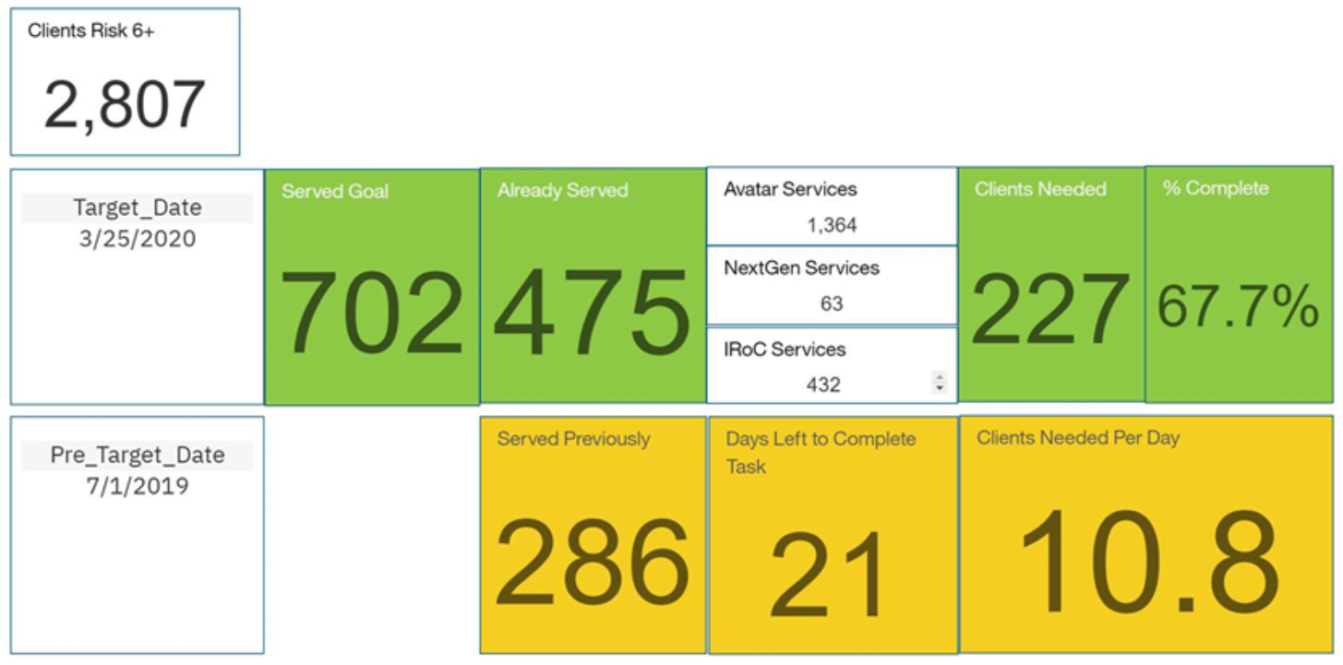

**Dashboard sent to team after reaching goal on 6/24/20.**

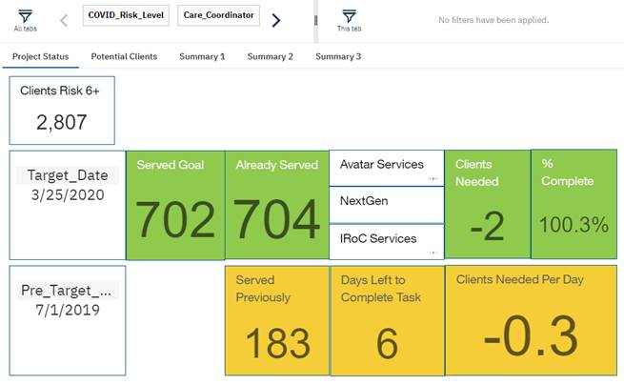

Program Development:

The COVID-19 outreach dashboard was developed over two days, between June 4& 5, tested June 8 and implemented June 9, 2020. The dashboard was developed to address an immediate need for Care Coordinators to track outreaches and progress towards successful completion of a high-risk COVID-19 deliverable assigned by The Department of Healthcare and Policy Financing. The responsibility of Care Coordinators, in relation to the deliverable, was to provide outreach to the members, provide COVID-19 specific education and establish further care coordination services as needed. Care Coordinators received their final list, with a goal of outreaching and engaging 702 high-risk COVID-19 members, with only 21 days and 15 working days to complete the task.

Program Information:

In order to successfully develop the COVID-19 outreach dashboard a series of strategies were implemented:

* Assessing the problem:
  + The sub-population of high-risk COVID-19 members assigned to our care coordination team by the RAE contained 2,807 members. That list was compared to our current Electronic Health Records (EHR) and we identified 439 high-risk COVID-19 members who had been referred on previous months COVID-19 outreach lists, had already received care coordination outreach and would fall into the timeframe of the metric. This knowledge allowed us to gain a firm understanding of the number of members our care coordinators needed to outreach in order to meet our goal.
* Previous engagement prioritized
  + By comparing the list of high-risk COVID-19 members to our EHR systems, we learned there were 295 members that Care Coordinators had successful contact with since January 1, 2020. These 295 high-risk COVID-19 members were believed to have a higher probability for successful contact again, thus were prioritized for outreach.
* Dashboard creation and engagement
  + The high-risk COVID-19 member list was imported into our analytics tool, Cognos, to initiate development of the dashboard and selection of outreach statistics.
  + A series of key outreach statistics were selected and organized to communicate to care coordinators and present progress towards our goal. Those key outreach statistics are:
    - Total # of members to reach the goal (Shown on dashboard as ‘Served Goal)
    - Total # of members outreached (Shown on dashboard as ‘Already_Served)
    - Total # of members needed to reach goal (Shown on dashboard as ‘Clients Needed’)
    - Percentage of goal completed (Shown on dashboard as ‘& Complete’)
    - Number of members prioritized for outreach (Shown on dashboard as ‘Served Previously’)
    - Number of days left to complete the goal (Shown on dashboard as ‘Days Left to Complete Task’)
    - Number of members to outreach per day to complete the goal (Shown on dashboard as ‘Clients Needed Per Day’)
    - Deliverable start date (Shown on dashboard as ‘Target_Date’)
    - Deliverable end date (Shown on dashboard as ‘Pre_Target_...”)
  + The dashboards general design function was developed to aid in tracking of outreaches provided by care coordination staff to attain our outreach goal of 702 high-risk COVID-19 members. In order to maximize effectiveness of the dashboard we used the following techniques to increase care coordinator engagement with the tool:
    - Education was provided to Care Coordination staff on how to use the dashboard.
    - A permanent link to the dashboard was sent to all Care Coordination staff.
    - The dashboard was designed to update every six hours, allowing care coordinators to see frequent progress.
    - An updated dashboard was sent to all Care Coordination staff each morning to keep engagement to the deliverable at a high level.

Staffing Requirements:

The staff involved in this project included:

* 1 Chief Information Officer (CIO)
* 1 Director of Care Coordination
* 14 Care Coordination staff

Initial development required communication between CIO and the Director of Care Coordination. Subsequent communication was primarily between the Director of Care Coordination and Care Coordination staff regarding the effectiveness of the dashboard. Care Coordinators immediately responded positively to the dashboard, stating it allowed them to understand what they needed to do and the timeframe they had meet their goal. Care Coordinators have requested a similar dashboard for our Complex Care Members that we are currently working on.

As stated above, this project took only two days to move from the member list to functioning dashboard with the only essentials being a list of client/patients/members who require a defined outreach or intervention, a data analytics tool with a technical person who has the ability to operate it and a team focused on reaching their goal.

Innovative Aspects:

The use of a data analytics dashboard to provide guidance, focus and engagement towards the deliverable goal was new to our care coordination staff. The quick and efficient development of the dashboard proved that this project can be easily replicated in other arenas by similar Community Mental Health Center’s. Although the COVID-19 outreach dashboard was the key tool used in this project, all strategies and techniques used to assess the problem, prioritize members and keep care coordinators engaged with and utilizing the dashboard played a key role in the team’s success.

The COVID-19 outreach dashboard continues to track outreaches for high-risk COVID-19 members even after the deliverable was met and had been reported on. This allows us to track new high-risk COVID-19 members that are currently being outreached by care coordinators and quickly and efficiently provide that information for reporting purposes.

Pertinent data:

Specifics:

Care Coordinators received final outreach list and initial dashboard with 21 days to complete.

Care Coordinators completed final outreach goal 6 days ahead of time.

Care Coordinators outreached a total of 702 members to reach goal.

The only data needed for this project was:

* The original list of high-risk COVID-19 members, provided by the RAE, to be included in the deliverable.
* Electronic Health Record systems
  + Avatar
  + NextGen
  + Integrated Registry of Care (IRoC)