2020 Golden Abacus Award
for Best Practices in the Non-Clinical Arena

Program Title: Friendraiser 2020: Honoring Behavioral Health Champions

Organization: The Center for Mental Health

Contact Name: Kateylyn Metcalf

Contact Phone #: 970-252-3200

Contact Email: Kmetcalf@centermh.org

Program Abstract

Every year The Center for Mental Health hosts a large community celebration to honor local Behavioral Health Champions throughout our six counties. It’s an important way we breakdown the stigma around behavioral health in rural Colorado. This year, COVID-19 forced us to cancel and we had to get creative about honoring our champions and their important work.

Program Description

Program Information: Each year, we celebrate three categories of Behavioral Health Champions for their work in breaking down the stigma associated with behavioral health in rural Colorado. This might be through advocacy, partnership, fundraising, or sharing their lived experience. Our champions include a Regional Behavioral Health Champion, a Lived Experience Champion and a Staff or Volunteer Champion. This year we had five champions from across our region.
We had to cancel our in-person celebration event which was set to kick off Mental Health Awareness Month on May 12 due to COVID-19 precautions. We felt it was important to honor our champions and their important work. Instead, we pivoted to an all-virtual celebration around International Friendship Day on July 30, 2020.
The integrated virtual celebration of the 2020 Behavioral Healthcare Champions consisted of social media such as a Facebook video from our CEO Shelly J. Spalding celebrating each of them and individual Facebook announcements for each champion celebrating their achievements. Social media also included an Instagram story. We ran a MailChimp email campaign to all of our community partners and supporters that had at least a 32% open rate. We created new web content dedicated to our Friendraiser event and our champions.
Website: Our new Friendraiser webpage which highlighted each recipient and the video from our
CEO garnered 415 views in a few days, a huge turnout for us.
Facebook Campaign: We launched a “Congratulations Champions” ad campaign on Facebook with a budget of $140. The campaign delivered 12,000 Video Plays, with over 7,000 watching at least 15 seconds. This alone generated over 13,000 ad impressions for our organization and our champions.
The organic posts highlighting each of our champions were a huge success – more than we imagined. In total, these posts reached over 4794 people and generated 1038 engagements. Our top post was celebrating Majacemeno Gallegos for his work in championing recovery from substance use, and it

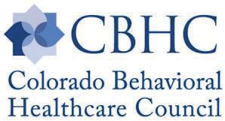2020 Golden Abacus Nomination Form

alone reached 2,623 people with over 654 engagements and 923 clicks: Definitely our most engaging organic post of the year.
See below:
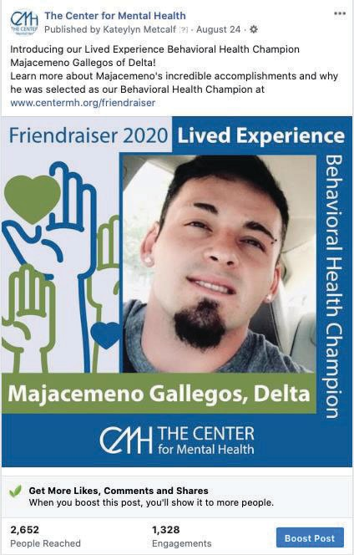

See our program poster for more of our champions.

Transferable and Repeatable: This effort is one that is repeatable by other community mental health centers across our region. It is of a lot work to get the nominations and to choose from so many great candidates, as well as to promote an online celebration, but it is a highly successful way to engage your community in the mission of breaking down the stigma around behavioral healthcare so people can get the care they need.
Staff Required: Part time of the two marketing team staff, graphic designer, and social media coordinator.
Costs: $140 in advertising costs, plus staff, Board, and graphic design time.

2

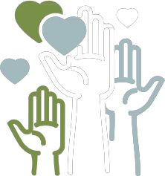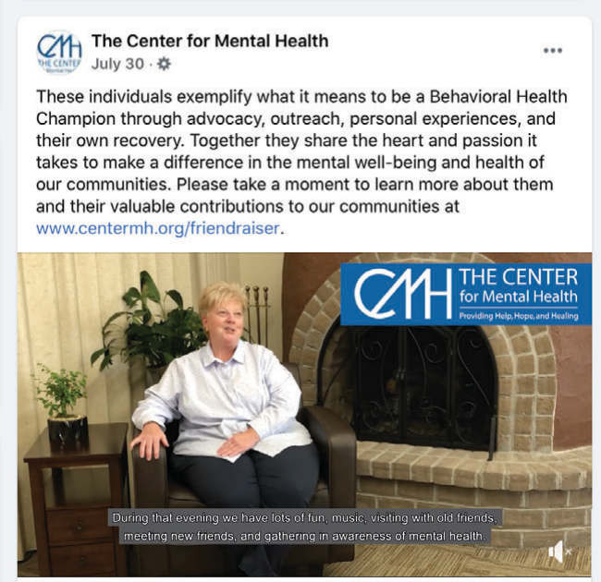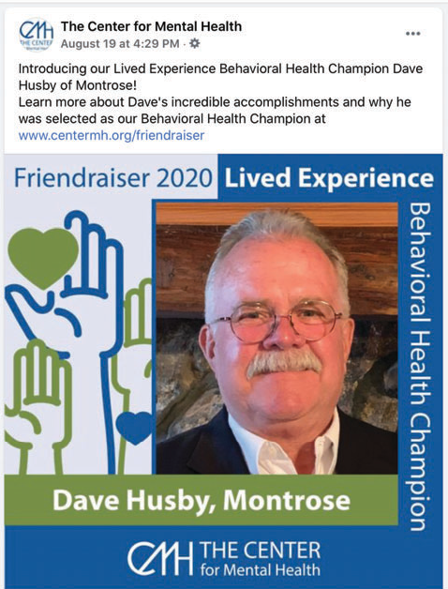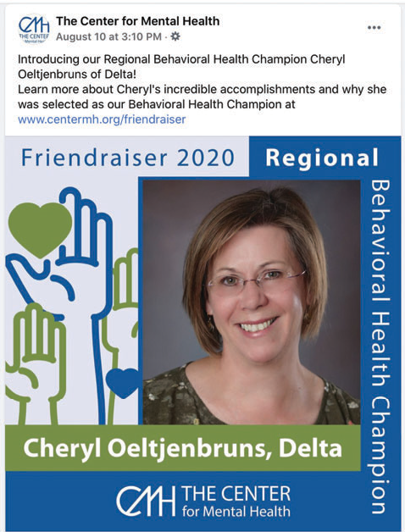Friendraiser 2020:
Honoring Behavioral Health Champions

Virtual Celebration

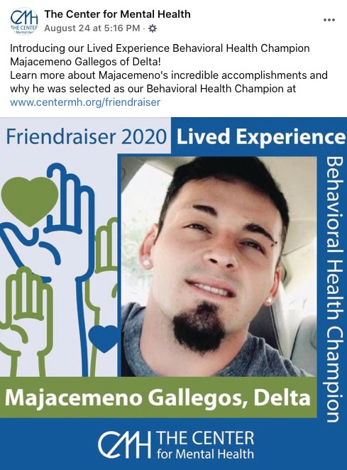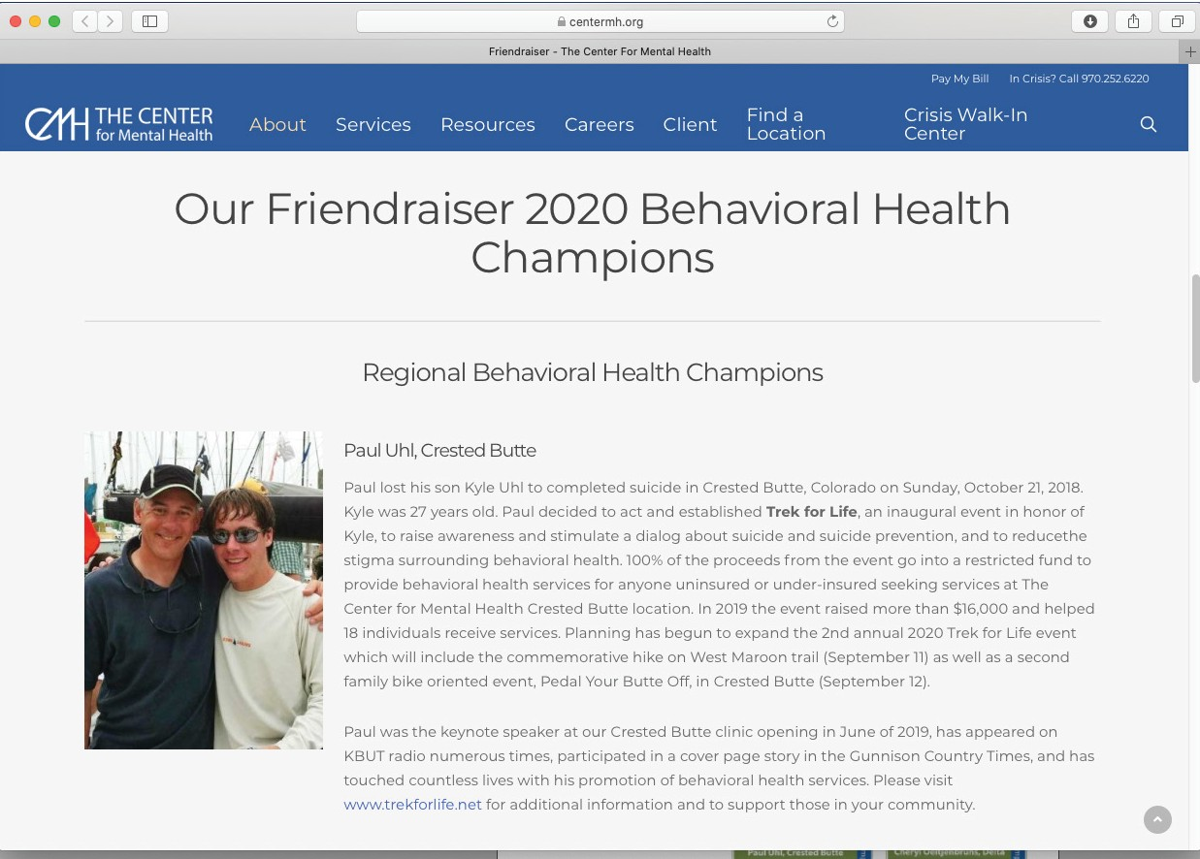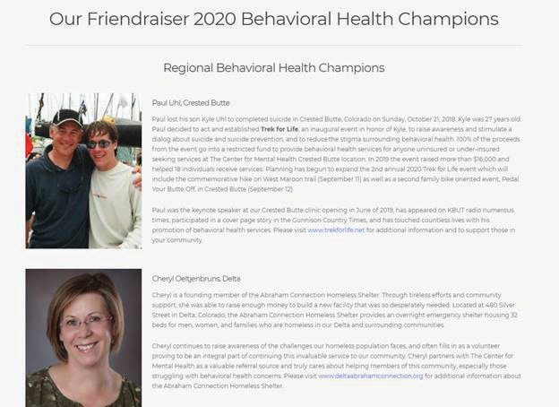Every year The Center for Mental Health hosts a large community celebration to honor local Behavioral Health Champions across our six counties. It’s an important way we breakdown the stigma around behavioral health in rural Colorado. This year, COVID-19 forced us to cancel, and we had to get creative about honoring our champions and their important work.

