

**2020 Golden Abacus Award**



***for Best Practices in the Non-Clinical Arena***

**Program Title: COVID-19 Outreach**

**Organization: The Center for Mental Health**

**Contact Name: Kateylyn Metcalf**

**Contact Phone #: 970-252-3200**

**Contact Email:** [**Kmetcalf@centermh.org**](mailto:Kmetcalf@centermh.org)

**Program Abstract**

At The Center for Mental Health, each of our programs, services, and locations have been impacted by COVID-19. Our communities were faced with a pandemic, and we rose to the challenge of helping those in our communities cope by rapidly expanding and promoting our offerings across our region.

**Program Description**

**Quality Improvement – Telehealth:** The safer-at-home/stay-at-home orders meant many people would stop coming into our locations for services. Our telehealth services were not only convenient, but necessary. We launched a widespread teletherapy marketing campaign to ensure all within our region knew they had options to access our services safely. This included communications in online and print newspapers, radio advertisements around the clock, paid and organic social media spreads on all our channels, and updating program information to reflect the integration of telehealth. Our Google Grant campaign highlighted telehealth and our new webpage saw over 1000 views.

**Innovation and Usefulness - The Center Support Line:** We expanded our local 24/7 Crisis Line to better serve our communities by offering 24/7 “warm line” support to those who are not at the point of a crisis but are experiencing emotional distress. The Center Support Line continues to provide free support with our specially trained, local staff who can help them through their experience. Communication efforts on all our platforms from print to email to social media widely promoted this to the public. Our call line data indicates successful implementation and our increased ability to help people get the services they need.

**Innovation - Coping with COVID Live Facebook Chats:** We started a series of live Facebook videos called *Coping with COVID*. Every Tuesday at noon we would sign into our Facebook channel and our clinical staff would discuss different topics that brought insight to current situations and experiences. We held this live so that viewers could send questions to us and we could answer them in real-time. This effort demonstrated real, human emotion, brought stories and examples to shared experiences, and provided comfort to those seeking answers.

In total, our original videos received 6,517 views. Our most popular topics were “Nurtured by Nature”, “Healthy ‘ING’ Activities”, “Dealing with Anger and Frustration”, and “Drinking Habits During COVID”. We also ran paid promotion of some of our videos to increase our reach. Our budget of less than

$100 reached 5400 people on Facebook.

**2020 Golden Abacus Nomination Form**



**Transferable - Partnership:** Beyond our own efforts, we worked weekly with our RAE 1 partners at MindSprings, Summit Stone, and Axis Health System to share each other's online and digital content using the #healingtogethercolorado hashtag. This was a way to maximize exposure of each of our content for the benefit of all our communities. It also led to operational and service benefits during this time.

**Integration and Transferable - New COVID-19 Website Section:** It quickly became apparent that there was huge need for information and resources on coping with mental health challenges. We created a new section of our website and partnered with other CMHCs to create and post content quickly and efficiently. This new COVID-19 section housed our service updates, letters from our CEO;

9 printable resource PDFs on topics from “Staying socially distant while physical distancing” to others.

In some cases, we worked with CMHC partners to adapt and share content so we could maximize impact efficiently.

This resource landing page has had close to 700 views which is very high for our website demonstrating usefulness of the resources.

**Patient/Client Experience - COVID-19 Blog Content:** Recognizing the need for our communities to hear from our clinicians on a range of topics led us to create a successful COVID-19 blog series ranging from “Managing Anxiety During COVID” (570 views) to “Drinking Habits During COVID” (260 views).

These blogs were supported with Facebook ad and email to our communities. These boosted posts on Facebook reached almost 20,000 people for $215 and generated 440 clicks to our website content. Two of our most popular blogs promoted on Facebook were “Managing Anxiety with COVID-

19” and “Drinking Habits During COVID-19”, the content of which aligned with our Live Facebook videos.

**Patient/Client Experience - Awareness of Key Services:** The safer-at-home/stay-at-home orders meant clients could not visit our locations. We launched a widespread teletherapy marketing campaign to ensure everyone knew this option was available. This included online and print

newspaper ads, radio ads, and paid and organic social media. We highlighted continued availability of

Same Day Access for New Clients via teletherapy options as well.

In addition, we sent regular “Covid Community Update” email campaigns to all our community

contacts to keep them informed, updated, and connected to us. Our open rate was typically between

45% and 50%. We also utilized a mix of local radio advertising, public service announcements, print and digital newspaper ads for localized COVID-specific updates. Once re-opened, communications

changed again, this time sharing our in-person safety protocols.

Our goal is to promote help, hope, and healing across our six-county region. During this unprecedented time, our communications efforts took on greater importance as it is our responsibility to help our communities and clients cope with behavioral health challenges.

**Staffing Resources:** Kirsten Mau, Director of Marketing & Communications; Kateylyn Metcalf, Marketing & Communications Coordinator; with the assistance of a part time graphic designer and part time social media coordinator.

2

Covid-19 Outreach

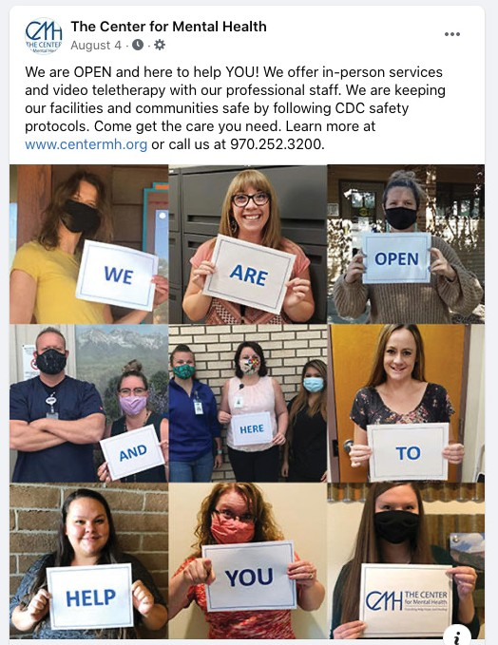

**Website**

*At The Center for Mental Health, each of our*

*programs, services, and locations have been impacted by COVID-19. Our communities were faced with a pandemic, and we rose to the challenge of helping those in our communities cope by rapidly expanding and promoting our offerings across our region.*

**Social Media Posts/Print Ads**

any

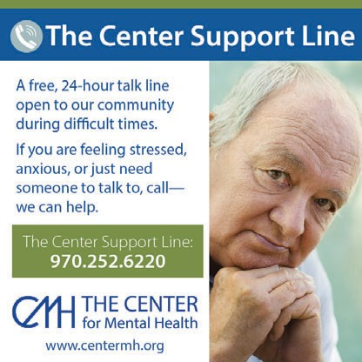

Stressed? Anxious? Overwhelmed?

*We’re here to help.*

The Center for Mental Health offers m

family and youth-focused services, including:

• Child and Adolescent Counseling • Family Counseling

• Substance Use Counseling for Teens • Play Therapy

We are here for you and your family. Many of our services are also conveniently offered via teletherapy.

Call 970.252.3200 to learn more or schedule an appointment.

Montrose: 605 E. Miami Rd. [www.centermh.org](http://www.centermh.org/)

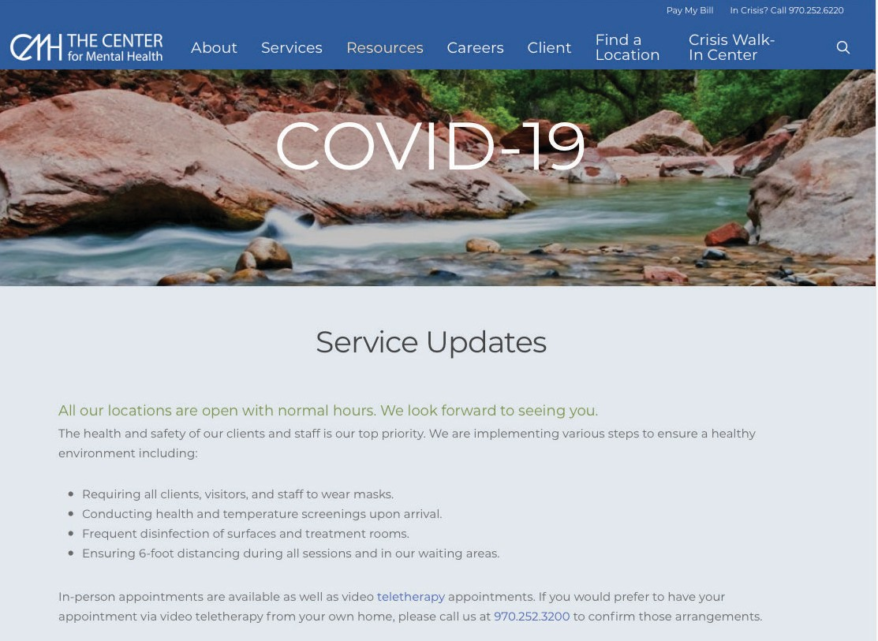

In Crisis? Call 970.252.6220 or text TALK to 38255 • Free and available 24/7/365

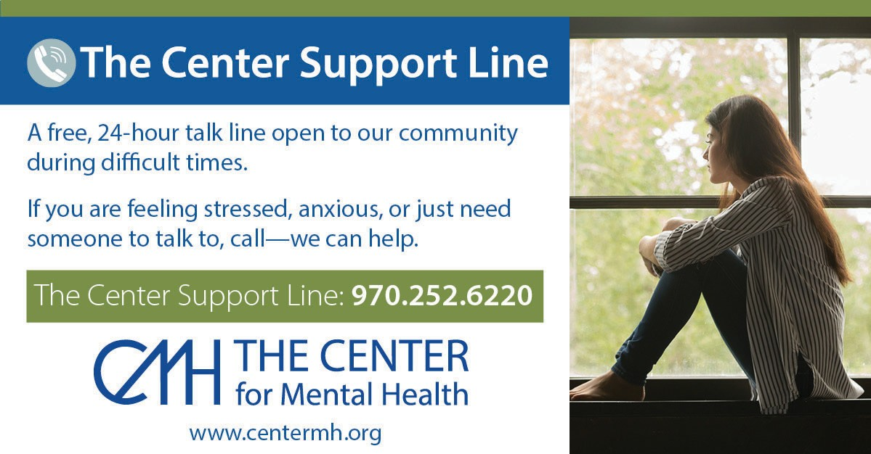

**Web Handouts**



**Staying Socially Connected While**

**Physical Distancing**

**Blog Posts Telehealth**

Teletherapy Services

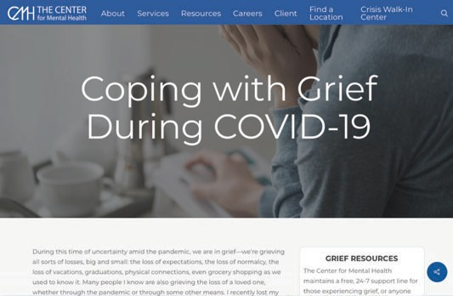

Behavioral Healthcare at Home

The current COVID-19 public health issue and its many despair and anxiety – even among those who haven’t are common reactions in times of uncertainty or when connection has proven critical to providing support for stress. However, in an era of physical distancing, it may support to friends and family.

there’s a perception of danger. Social these feelings, and for helping reduce seem challenging to provide this type of

**support during this challenging time:**

**tancing**

between family, friends, neighbors and

phone call can make the difference. updated and connected, as well as foster

urage family and friends to do the same.

Everyone is making it up as they go along

news and enjoy other activities.

**meone is Reaching Out for Help**

eat a physical health issue. Do not hesitate

1.844.493.8255 (TALK) or text TALK to 38255.

ommunity during difficult times. someone to talk to, call—we can help.

**Line: 970.252.6220**

learn more or to make an appointment.

from Mental Health Partners.

stressors can increase feelings of isolation, experienced these feelings in the past. These

**See below for information on how to provide**

**Connecting During Physical Dis**

• Utilize technology to bridge the physical distance colleagues.

• Check-in with people often – even a quick text or

• Get online. Social media is a wonderful way to stay social connections with those around you.

**Take Care of Yourself**

• Practice self-care and mindfulness – and enco

• You don’t have to be “perfect” to cope successfully. and doing their best.

• Set aside time everyday to step away from the

**Recognize and Respond When So**

Treat a mental health issue the same way you would tr to check back in regularly as a trusted resource.

**Seek Professional Help**

**Are you experiencing a crisis?** Call 970.252.6220 or

**In Uncertain Times, Anxiety and Stress Can Increase**

It is understandable that individuals can feel overwhelmed with emotions like fear, anxiety and stress. These emotions can manifest in:

• Changes in sleep or eating patterns

• Difficulty sleeping or concentrating

• Worsening of chronic health problems

• Increased use of alcohol, tobacco or other drugs

**Everyone Reacts Differently**

It is also important to remember that everyone reacts differently to stressful situations. How a person responds to the current situation can depend on your background, the things that make you different from other people, and the community you live in. There is no right or wrong way to respond to something of this magnitude. Having patience with yourself, and your loved ones, will help navigate through this challenging time. Keep in mind individuals listed below may respond more strongly to this kind of stress:

• Older people and people with chronic diseases who are at higher risk for COVID-19

• People who have mental health conditions including problems with substance use

• People who are helping with the response to COVID-19, like doctors and other health care

We offer secure teletherap sessions via phone and video conference so you can get the care you

y

**chedule**

need from home. Connect with us at any of our locations from wherever you may be.

**Call 970.252.3200 to s**

**an appointment or learn more.**

[www.centermh.org/teletherapy](http://www.centermh.org/teletherapy)

**Need someone to talk to?**

Call The Center Support

Line 24/7 at 970.252.6220

A free, 24-hour talk line open to our c



If you are feeling stressed, anxious, or just need

**The Center Support**

providers, or first responders

• Children and teens

**Knowing the Facts Can Reduce Stress**

One way to reduce stress is to check reputable sources about COVID-19. A great resource to check regularly is the **Centers for Disease Control and Prevention,** [**www.cdc.gov**. They have](http://www.cdc.gov.Theyhave/) a full site that provides the latest information and facts on COVID-19, including how to keep yourself healthy; what to do if you get sick; resources for caregivers; and more.

**In crisis?** Text TALK to 38255 or call 1.844.493.8255

www.centermh.org • Call 970.252.3200 to

Content reproduced with permission

A free, 24-hour talk line open to our community during difficult times.



If you are feeling stressed, anxious, or just need someone to talk to, call—we can help.

**The Center Support Line: 970.252.6220**

www.centermh.org • Call 970.252.3200 to learn more or to make an appointment.

Content reproduced with permission from Mental Health Partners.