2020 Golden Abacus Award
for Best Practices in the Non-Clinical Arena

This year, CBHC will be utilizing a virtual platform for our conference. We will still accept nominations for the Golden Abacus Award; however, we will acknowledge the winner after the conference in a special ceremony.

We encourage you to submit your nomination not only to CBHC but also to include information on your project in our Poster Hall within the virtual platform. Please review the following information:

The Committee of Data, Finance and Budgeting is currently accepting nominations for the Colorado Behavioral Healthcare Council’s (CBHC) annual Golden Abacus Award. Nominees in this category must pertain to programs within the community behavioral health system. The award will be granted to a project, methodology, technology system, or procedure that demonstrates best practice in the non-clinical arena. All nominations will be evaluated on the following criteria:

♦ Innovation
♦ Integration
♦ Quality Improvement
♦ Transferable
♦ Usefulness
♦ Patient/Client Experience
♦ Data-driven Solution

The winning program will be one that is easily replicated at any community behavioral health center or provider organization. Its implementation will result in a superior service, process, or product (i.e. cost reduction, outcome improvement, and enhanced patient/client/staff experience). Results must be data-driven. The committee will consider proposals that demonstrate innovative approaches to the management of, or implementation of, systems or organizations. Submissions may be in the areas of:

♦ Research/Research Findings
♦ Finance
♦ Personnel
♦ Quality improvement

♦ Systems/services/program integration
♦ Use of technology
♦ Partnerships/alliances

All proposals must include a fifty (50) word Abstract, a Program Description (limited to 2 pages) that includes program development information, innovative aspects, and pertinent data. Please use the following form.

We also encourage you to UPLOAD YOUR PROJECT TO OUR CONFERENCE’S ONLINE PLATFORM POSTER PAGE TO SHOWCASE YOUR TALENT. Please note that we do not require an actual “poster.” You are welcome to simply upload the information provided in this nomination form.

Please submit your nomination no later than SEPTEMBER 1, 2020 to: Tracy O’Shaughnessy, Conference Planner, at tracyhmsr@gmail.com. She will follow up with instructions on how to upload your information to the site. It must be uploaded no later than SEPTEMBER 7, 2020. We are very excited to be able to offer this opportunity to you this year. Questions: Call Tracy at 303-525-2811.

Program Title: STAR-Support Team Assistance Response

Organization: Mental Health Center of Denver

Contact Name: Amy Sarrazin Contact Phone # 303-504-6635

Contact Email: amy.sarrazin@mhcd.org

Program Abstract (50 words max, please):

STAR is a crisis alternative response that sends a paramedic and clinician to low-risk behavioral health calls coming across 911 to de-escalate and connect a resident in distress with appropriate services. Providing a broad range of no cost services including information, referrals, crisis intervention, counseling, transportation solutions, and social service needs.

Program Description (Include program development, program information, staffing requirements, pertinent data and start-up costs.): *Please limit to 2 pages, and remember to address all criteria specified.

Following the five-year growth and success of Mental Health Center of Denver’s collaboration with the Denver Police Department for the Co-responder program, discussions began on solution-based options to low level 911 calls. In May 2019, a visit to Eugene, Oregon with community members, Denver police, and Mental Health Center of Denver staff discovered just this type of response. The collective group gathered information from Eugene’s CAHOOTS program and brought it back to Denver for discussion and replication. Caring for Denver funding allowed for request of a pilot program to establish this unique civilian led 911 response that complimented Co-Response models but addressed the immediate situation without law enforcement presence or need. Starting in June 2020 the Denver STAR (Support Team Assisting response) pilot was initiated. A partnering between Denver Health Paramedics and Mental Health Center of Denver Clinicians allows for a harm reduction, solution-focused approach to what is happening in the community and allows law enforcement to focus on other needs and leaves low level behavioral health issues to the professionals.

The STAR pilot provides crisis de-escalation, connection, and system navigation for anyone utilizing the STAR dedicated phone number or 911 and assists in supporting client self-identified needs. This includes access to low barrier treatment options, reconnection to service providers or safe locations identified by the client, as well as transport to identified supports as needed. Additional case management support can be utilized to tap into support and system navigation post crisis (Mental Health Center of Denver crisis case management team or
other community resource). The 911 dispatcher is responsible to dispatch the STAR team to assist with intoxicated persons, suicidal ideation with no safety components, welfare checks, indecent exposure, trespassing. and syringe disposal.

LOGISTICS: To access the resources of the STAR program community members can call the direct line 720-
913-STAR or 911. The Denver 911 Communications Center will triage these calls to determine if the call is appropriate for a STAR response. During the hours the STAR van is operational (M-F 10am-6pm) it will respond to the scene of these appropriate calls. The STAR van will be staffed with a Denver Health Paramedic and a Mental Health Center of Denver clinician. The primary calls are focused on low-risk mental health and/or substance use issues, they can also access and triage minor medical issues. If more serious medical emergencies are encountered, they will request a fully operational Denver Health ambulance with Advanced Life Support capabilities. The goal of the STAR program is to address the initial crisis on the street, and to direct, refer, and transport the client to support services for long term solutions to issues of mental health and substance use.

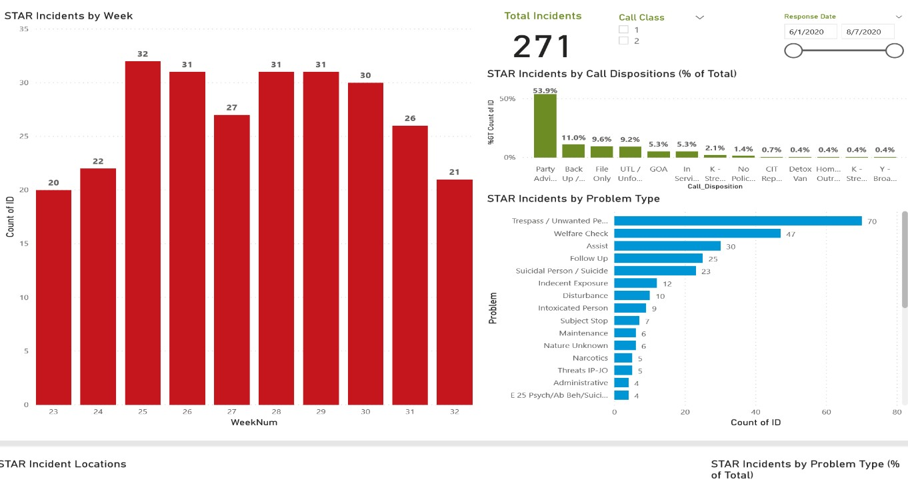

Data Overview
Through the first 10 weeks of service (June 1, 2020 – August 7, 2020), STAR responded to 271 incidents or
27.1 per week or 5.42 per 8-hour shift. The STAR unit can be associated to a call for service through three general mechanisms: 1) 9-1-1 call takers flagging incoming calls and directly dispatching the STAR unit (109
[40.2%] incidents), 2) uniformed response independently requests STAR to respond on scene (107 [39.5%]
incidents), and 3) STAR self-initiates a response in the field (55 [20.3%] incidents). STAR’s operational footprint has been concentrated in DPD District 6 (see: figure 1) with a few incidents outside of this area, most notably around the overflow shelter at 4655 N Humboldt St.

In total, 9-1-1 call takers flagged 402 calls for service, of which STAR has responded to 109 (27.1%) while traditional uniform response fielded 293 (72.9%) calls for service. The median STAR response required 26.07 minutes of on-scene personnel time to resolve; traditional responses required 33.31 minutes (i.e., a traditional response required 7.24 more minutes [27.8%] at the median to resolve). To date no police back up have been needed on any of these calls for service.

