Certified Community Behavioral Health Clinics (CCBHC) Overview

First introduced federally under Section 223 of the Protecting Access to Medicare Act (PAMA) of 2014 (Public Law 113-93), Certified Community Behavioral Health Clinics (CCBHCs) provide a robust range of mental health and substance use disorder (SUD) services to vulnerable individuals. CCBHCs can be supported through the CCBHC Medicaid Demonstration, Substance Abuse Mental Health Services Administration (SAMHSA), CCBHC Expansion (CCBHC-E) Grants, or independent state programs authorized through an 1115 waiver or State Plan Amendment. There are now at least 430 CCBHC sites nationwide.

National research has found that since the advent of the demonstration program CCBHCs have dramatically increased access to mental health and SUD treatment, supported behavioral health provider workforce development, expanded capacity to address the opioid crisis and other substance use disorders (SUD), and established innovative partnerships with law enforcement and hospitals to improve care and reduce recidivism and readmissions. These impacts have garnered congressional support. The Bi-Partisan Safer Communities Act includes a significant expansion of the CCBHC demonstration program. Each U.S. State could have an opportunity to participate in a CCBHC demonstration by the year 2030.

CCBHCs must serve all clients regardless of ability to pay, and adhere to rigorous, uniform data collection requirements that demonstrate value. Like federally qualified health centers, (FQHCs), CCBHCs are required to provide a federally defined array of services, with an emphasis on the utilization of evidence-based practices. These include:
- Crisis mental health services
- Screening, assessment, and diagnosis
- Patient-centered treatment planning
- Outpatient mental health and substance use disorder services
- Primary care screening and monitoring
- Targeted case management
- Psychiatric rehabilitation services
- Peer support services and family support services
- Services for members of the armed services and Veterans.
Four community behavioral health providers have been awarded SAMHSA CCBHC-E grants. These centers are leading the way towards statewide adoption of a care model based on the federal demonstration, in exchange for an alternative payment methodology that supports population health and value-based care.

Community Mental Health Center | Regional Accountable Entity Region
Aurora Mental Health Center | Region 3, Colorado Access
Mental Health Partners | Region 6, CCHA
North Range Behavioral Health | Region 2, Northeast Health Partners
Southeast Health Group | Region 4, Health Colorado

All four centers are participating in the CCBHC Learning Collaborative (the Collaborative), facilitated by Third Horizon Strategies (THS) under a contract with Colorado Behavioral Healthcare Council. The Collaborative convenes monthly to share best practices and lessons learned and to collectively problem solve. Members also receive individualized leadership and strategy coaching monthly from THS.

CCBHC funding enables each of the four centers to expand access to care in their local communities and enhance service delivery and quality improvement. Some notable achievements to date include:
- Southeast Health Group (SHG) has continued cultivating community-specific programs, utilizing advisory committees for specific populations. CCBHC has helped enhance these committees, including the Agricultural and Veteran Advisory Committees. Through the committees, SHG has incorporated client and community voices into our needs assessment and program planning. The focus has shifted to setting up non-traditional access points to ensure that we are meeting our community members where they are through CCBHC.
- Mental Health Partners (MHP) launched a new Substance Use Disorder Intensive Outpatient Program (SUD IOP) and Anxiety IOPs for Adults and teens/caregivers. SAMHSA’s National Outcome Measures (NOMS) analysis for the Anxiety IOP indicates that 63% of adult clients experienced an improvement in overall functioning upon program completion, 50% of teen clients experienced an improvement in social connectedness, and 100% of clients (both adult and teen) reported a positive perception of care. Over 30 clients have participated in the SUD IOP, and the majority report positive experiences in care, including developing more confidence with coping skills, reduced substance use, and overall satisfaction with services. The MHP Community Health Worker (CHW) program, supported by CCBHC funding, is developing a robust sustainability plan to maintain this vital service after grant funding ends. MHP’s CHWs conduct proactive outreach to engage current and new clients in care and assist them in accessing other needed community supports. Read more here: https://www.mhpcolorado.org/community-health-workers/.
- Aurora Mental Health Center (AuMHC) has focused on strengthening staff expertise through expanded training programs, providing nearly 8,000 hours of training in trauma-informed, culturally responsive patient-centered care and clinical evidence-based practices; improving coordination of care through dedicated care coordinator positions, and developing internal and external referral systems; and measurement-based care through implementation of additional client screening tools and integration of outcomes to guide treatment planning and future population health management projects.
- North Range Behavioral Health (NRBH) is working to increase immediate access to care, engagement in care, and enhance services for underserved populations. They are also increasing center-wide data collection and quality improvement efforts and plan to utilize the NOMS for all new clients.

Colorado CCBHCs are compiling NOMS outcomes as part of their CCBHC award. To see a dashboard sample of those outcomes, scan the QR code below. The data is updated as of September 12, 2022, and includes measures from NOMS questionnaires, standard assessments for any individual entering the CCBHC programming.
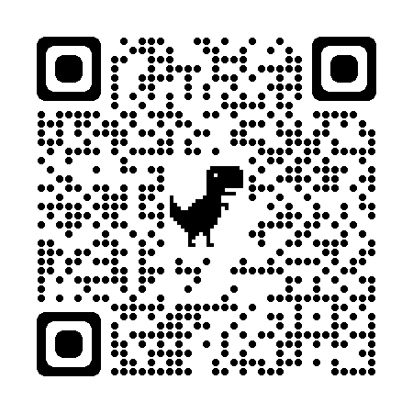

Additional Information and Resources

CCBHC Criteria: https://www.samhsa.gov/sites/default/files/programs_campaigns/ccbhc-criteria.pdf

FY 2021 CCBHC Grant Awards: https://www.samhsa.gov/grants/grant-announcements-2021

FY2022 CCBHC Notification of Funding Opportunity: https://www.samhsa.gov/sites/default/files/grants/pdf/fy-22-ccbhc-pdi-nofo.pdf

National Council for Mental Well-Being 2021 CCBHC Impact Report:
https://www.thenationalcouncil.org/wp-content/uploads/2021/05/052421_CCBHC_ImpactReport_2021_Final.pdf?daf=375ateTbd56

GAO 2021 CCBHC Report to Congress: https://www.gao.gov/assets/gao-21-394.pdf

Third Horizon Strategies is a boutique advisory firm focused on shaping a future system that actualizes a sustainable culture of health nationwide. The firm offers a 360º view of complex challenges across three horizons – past, present, and future– to help industry leaders and policymakers interpret signals and trends, design integrated systems, and enact changes so that all communities, families, and individuals can thrive. For more information, visit https://thirdhorizonstrategies.com or contact Mindy Klowden, MNM, Senior Director, at (303) 884-2670 or Mindy@thirdhorizonstrategies.com.

